When scoring X indicates a strike, / indicates a spare, - indicates a miss:

● 12 rolls: 12 strikes: XXXXXXXXXXXX = 10+10+10 + 10+10+10 + 10+10+10 +

10+10+10 + 10+10+10 + 10+10+10 + 10+10+10 + 10+10+10 + 10+10+10 + 10+10+10 =

300

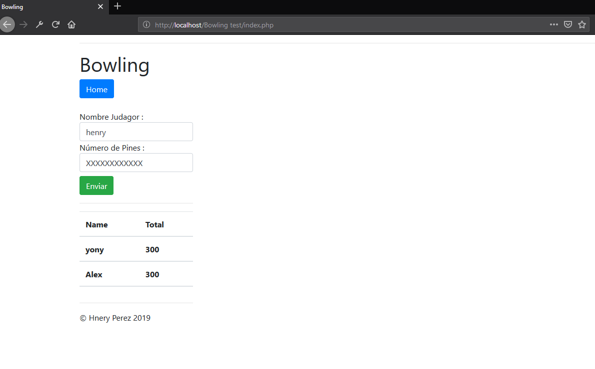

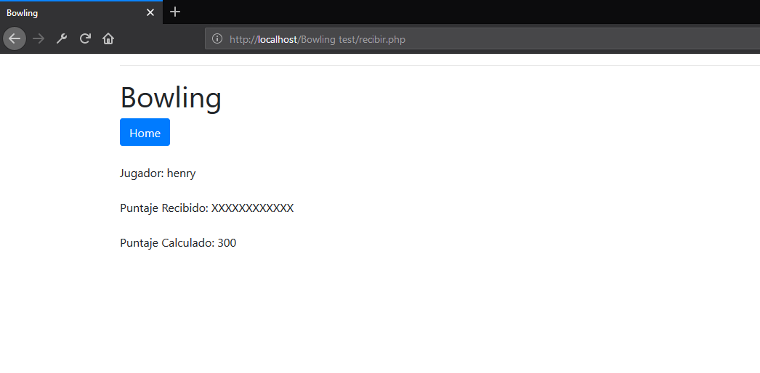

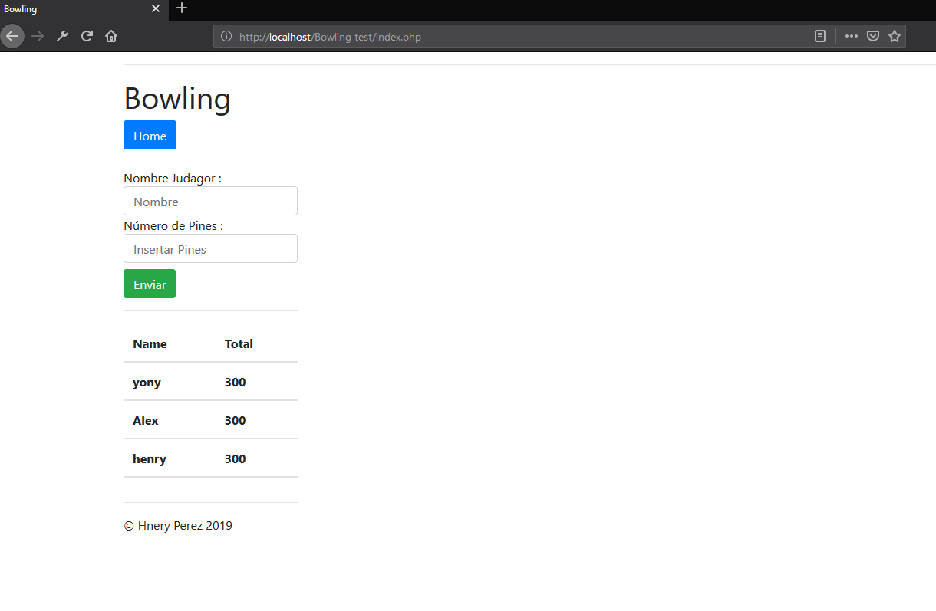

● 20 rolls: 10 pairs of 9 and miss: 9-9-9-9-9-9-9-9-9-9- = 9 + 9 + 9 + 9 + 9 + 9 + 9 + 9 +

9 + 9 = 90

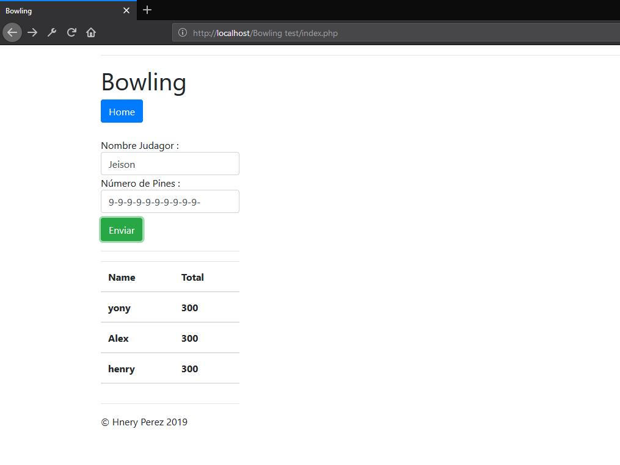

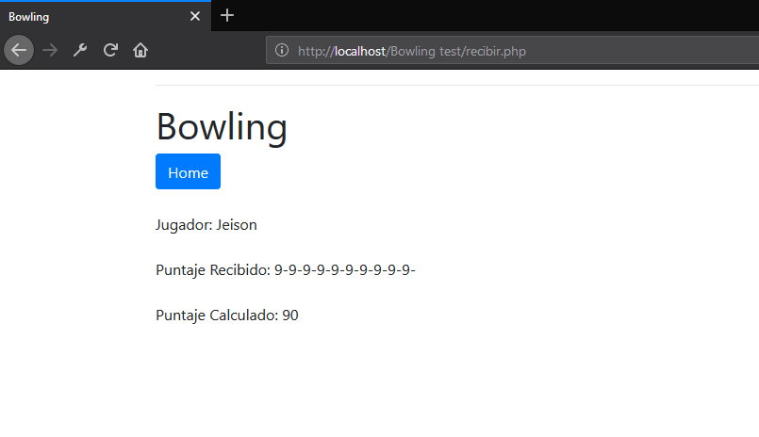

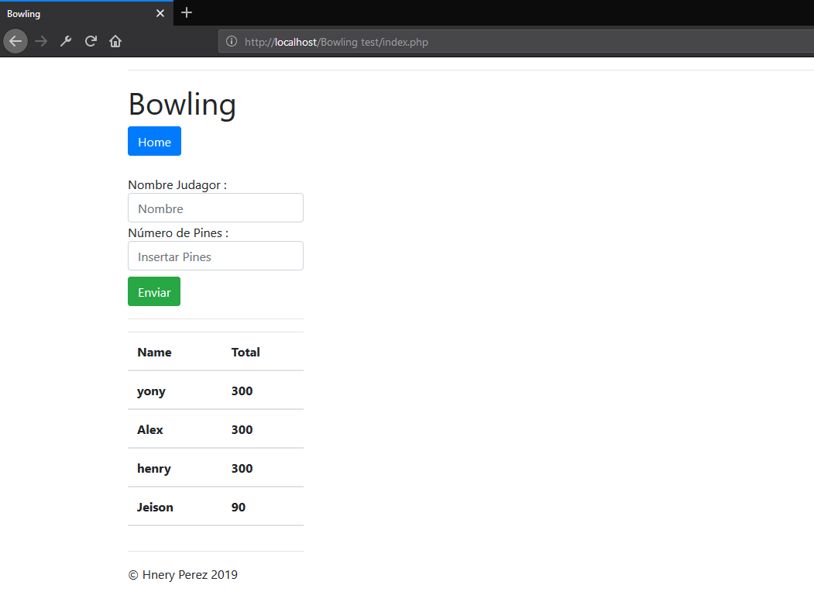

● 21 rolls: 10 pairs of 5 and spare, with a final 5: 5/5/5/5/5/5/5/5/5/5/5 = 10+5 + 10+5 +

10+5 + 10+5 + 10+5 + 10+5 + 10+5 + 10+5 + 10+5 + 10+5 = 150

